MANAV RACHNA INTERNATIONAL INSTITUTE OF
RESEARCH AND STUDIES

FACULTY OF ENGINEERING AND TECHNOLOGY
OOPS LAB FILE
NAME:EASHAN SHARMA
ROLL NO:1/19/FET/BCS/140
SUBJECT CODE:BCS-DS-302
PROGRAM-1
#WAP to print two numbers
#include<iostream>
using namespace std;
int main()
{
int a=5,b=6;
cout<<"The numbers are :"<<a<<" and:"<<b;
}
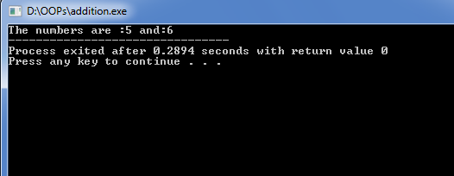
PROGRAM-2
2) a)# WAP to Swap two numbers using call by refrence
#include<iostream>
using namespace std;
int swap(int *x,int *y)
{
int temp;
temp=*x;
*x=*y;
*y=temp;
}
int main()
{
int a,b;
cout<<"Enter the numbers to be swapped\n";
cin>>a>>b;
cout<<"Before swap a is :"<<a<<" b is b:"<<b<<endl;
swap(a,b);
cout<<"After swap a is :"<<a<<" b is b:"<<b<<endl;
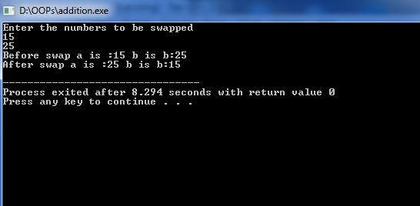
2) b)#WAP to swap two numbers using call by value
#include<iostream>
using namespace std;
int swap(int x,int y)
{
int temp;
temp=x;
x=y;
y=temp;
cout<<"After swap a is :"<<x<<" b is b:"<<y<<endl;
}
int main()
{
int a,b;
cout<<"Enter the numbers to be swapped\n";
cin>>a>>b;
cout<<"Before swap a is :"<<a<<" b is b:"<<b<<endl;
swap(a,b);
}
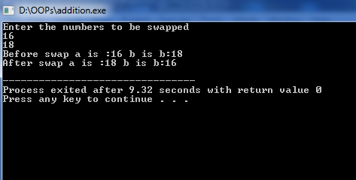
PROGRAM-3
#WAP to find volume of cube using inline functions
#include<iostream>
using namespace std;
inline int volume(int L)
{
return(L*L*L);
}
int main()
{
int a;
cout<<"Enter the side of cube\n";
cin>>a;
cout<<"Volume="<<volume(a);
}
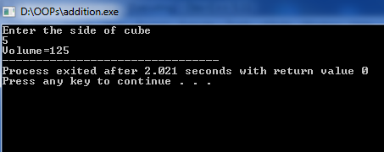
PROGRAM-4
#WAP to compute power of a number if power is not given by user then calculate square of number
#include<iostream>
#include<math.h>
using namespace std;
int power(int x, int y=2)
{
int result;
result=pow(x,y);
return result;
}
int main()
{
int a,x,m;
cout<<"Enter the number\n";
cin>>a;
cout<<"If you want to calculate more than square of number press 1\n";
cin>>x;
if(x==1)
{
cout<<"Enter the Power\n";
cin>>m;
cout<<"Result is:"<<power(a,m);
}
else
cout<<"Result is:"<<power(a);
}
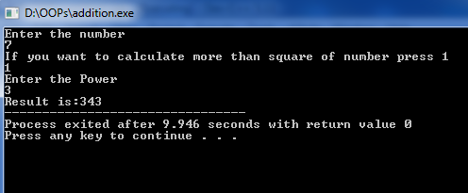
PROGRAM-5
#WAP to implement class and object using the following Name of customer, Account no, balance etc as data members getdata(),putdata(),credit(),debit() as member functions
#include<iostream>
using namespace std;
class bank
{
char name[50],acno[50],type[10];
int balance,depo,withd;
public:
void getdata()
{
cout<<"Enter name\n";
cin.getline(name,50);
cout<<"Enter account no\n";
cin.getline(acno,50);
cout<<"Credit or Debit Amount:\n";
cin.getline(type,50);
cout<<"Enter balance\n";
cin>>balance;
}
void deposit()
{
cout<<"\nEnter amount to be Deposited:\n";
cin>>depo;
balance=balance+depo;
cout<<"New balance:\n";
cout<<balance;
}
void withdraw()
{
cout<<"\nEnter Amount to be Withdrwan:\n";
cin>>withd;
balance=balance-withd;
cout<<"New Balance\n";
cout<<balance;
}
void putdata()
{
cout<<"\nName:"<<name<<endl;
cout<<"\nAccount no:"<<acno<<endl;
cout<<"\ntype:"<<type<<endl;
cout<<"\nbalance:"<<balance<<endl;
}

};
int main()
{
bank x;
x.getdata();
x.deposit();
x.withdraw();
x.putdata();
}
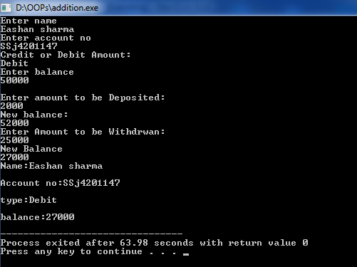
PROGRAM-6
#WAP to create class student with suitable data members and member functions to display marks of student and display the average marks
#include<iostream>
using namespace std;
class student
{
char name[50];
int age,i,sem,marks[6],sum=0,avg;
public:
void getdata()
{
cout<<"Enter name:";
cin.getline(name,50);
cout<<"Enter Age:";
cin>>age;
cout<<"Enter Semester:";
cin>>sem;
for(i=1;i<=5;i++)
{
cout<<"Marks of subject "<<i<<":";
cin>>marks[i];
sum=sum+marks[9];
}
avg=sum/5;
}

void putdata()
{
cout<<"\nName:"<<name<<endl;
cout<<"Age:"<<age<<endl;
cout<<"Semester:"<<sem<<endl;
cout<<"Average marks:"<<avg<<endl;
}

};
int main()
{
student s;
s.getdata();
s.putdata();}
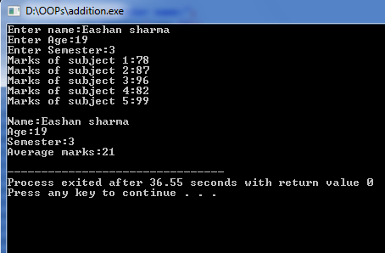
PROGRAM-7
#Demonstrate the concept of passing objects as arguments to a function
#include<iostream>
using namespace std;
class time
{
int hours,minutes;
public:
void gettime(int h,int m)
{
hours=h;
minutes=m;
}
void sum(time A,time B)
{
minutes=A.minutes+B.minutes;
hours=minutes/60;
minutes=minutes%60;
hours+=A.hours+B.hours;
}
void puttime()
{
cout<<hours<<" hours and "<<minutes<<" minutes\n";
}
};
int main()
{
time t1,t2,t3;
t1.gettime(2,45);
t2.gettime(3,30);
t3.sum(t1,t2);
cout<<"t1=";t1.puttime();
cout<<"t2=";t2.puttime();
cout<<"t3=";t3.puttime();
}
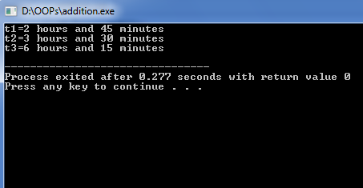
PROGRAM-8
#A phone number such as (212) 767-8900, can be thought of having three parts the area code(212) the exchange(767) and the number (8900).WAP that uses a structure to store these three parts separately. Create two structure variables and have the user enter both numbers and display them
#include<iostream>
using namespace std;
struct phone
{
int std1,cmp1,num1,std2,cmp2,num2;
}x;
int main()
{
cout<<"Enter 1st Phone Numbert\n";
cout<<"Enter Std code without(0):";
cin>>x.std1;
cout<<"Enter company code:";
cin>>x.cmp1;
cout<<"Enter phone no:";
cin>>x.num1;
cout<<"Enter 2nd Phone Numbert\n";
cout<<"Enter Std code without(0):";
cin>>x.std2;
cout<<"Enter company code:";
cin>>x.cmp2;
cout<<"Enter phone no:";
cin>>x.num2;
cout<<"1st number:"<<"("<<x.std1<<") "<<x.cmp1<<"-"<<x.num1<<endl;
cout<<"2nd number:"<<"("<<x.std2<<") "<<x.cmp2<<"-"<<x.num2<<endl;
}
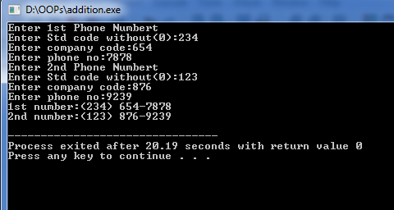
PROGRAM-9
#Demonstrate the concept of static data members
#include<iostream>
using namespace std;
class bank
{
static int count;
int number;
public:
void getdata(int a)
{
number=a;
count++;
}
void putdata()
{
cout<<"count:"<<count<<endl;
}
};
int bank::count;
int main()
{
bank a,b,c;
a.putdata();
b.putdata();
c.putdata();
a.getdata(1);
b.getdata(1);
c.getdata(1);
a.putdata();
b.putdata();
c.putdata();
}
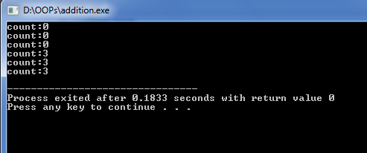
PROGRAM-10
#WAP to demonstrate different constructors
#include<iostream>
using namespace std;
class integer
{
int m,n;
public:
integer()
{
m=0;
n=0;
cout<<m<<" "<<n<<endl;
}
integer(int x,int y)
{
m=x;
n=y;
cout<<m<<" "<<n<<endl;
}
integer(integer &i)
{
m=i.m;
n=i.n;
cout<<m<<" "<<n<<endl;
}
};
int main()
{
integer int1;
integer int2(4,9);
integer int3(int2);
}
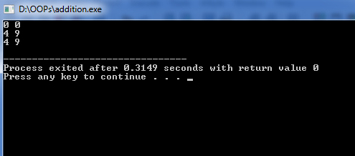
PROGRAM-11
#WAP to take feet and inches, metres and centimeters and convert into common unit using friend function
#include<iostream>
using namespace std;
class DB;
class DM
{
int m,cm;
public:
void get()
{
cout<<"metres:";
cin>>m;
cout<<"centimetres:";
cin>>cm;
}
friend void sum(DM&,DB);
}dm;
class DB
{
int f,inch;
public:
void get()
{
cout<<"Feet:";
cin>>f;
cout<<"inches:";
cin>>inch;
}
friend void sum(DM&,DB);
}db;
void sum(DM& dm,DB db)
{
int x=dm.cm+(db.inch*2.54)+(db.f*30.48);
dm.m+=x/100;
x-=(db.f*30.48);
dm.cm=x%100;
cout<<"Metres:"<<dm.m<<"centimetres:"<<dm.cm;
}

int main()
{
dm.get();
db.get();
sum(dm,db);
}
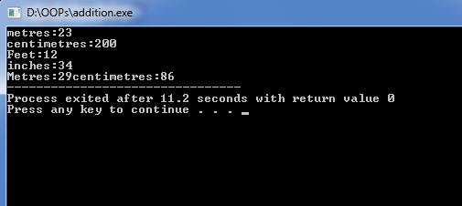
PROGRAM-12
#WAP to demonstrate destructor
#include<iostream>
using namespace std;
int count=0;
class div
{
public:
div()
{
count++;
cout<<count<<endl;
}
~div()
{
count--;
cout<<count<<endl;
}
};
int main()
{
div a,b,c,d;
{
cout<<"Creating object 5"<<endl;
div e;
}
{
cout<<"Creating object 6"<<endl;
div f;
}
cout<<"After closing main\n";
}
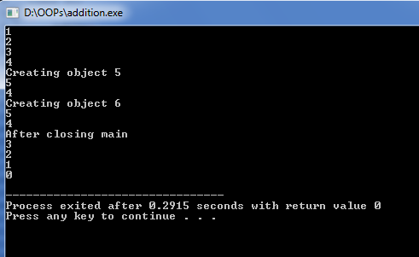
PROGRAM-13
#WAP to create a class hospital that enters and displays Name of patient, admission date, disease, discharge date.
#include<iostream>
using namespace std;
class hosp
{
string name,dis,admi,disc;
public:
hosp()
{
cout<<"Name of patient:";
cin>>name;
cout<<"Date of admission:";
cin>>admi;
cout<<"Disease:";
cin>>dis;
cout<<"Date of discharge:";
cin>>disc;
}
void display()
{
cout<<"Name of patient:";
cout<<name<<endl;;
cout<<"Date of admission:";
cout<<admi<<endl;
cout<<"Disease:";
cout<<dis<<endl;
cout<<"Date of discharge:";
cout<<disc;
}
};
int main()
{
hosp p1;
p1.display();
}
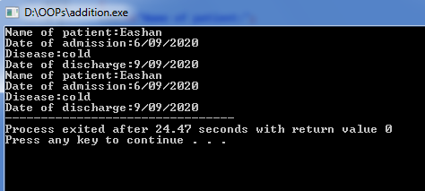
PROGRAM-14
#WAP to implement operator overloading of binary+ operator
#include<iostream>
using namespace std;
class comp
{
float x,y;
public:
comp(){}
comp(float real,float imag)
{
x=real;
y=imag;
}
comp operator+(comp c)
{
comp temp;
temp.x=x+c.x;
temp.y=y+c.y;
return(temp);
}
void display()
{
cout<<x<<"+i"<<y<<endl;
}
};
int main()
{
comp p,q,r;
p=comp(2.5,3.5);
q=comp(4.4,6.8);
r=p+q;
cout<<"P=";p.display();
cout<<"Q=";q.display();
cout<<"R=";r.display();
}
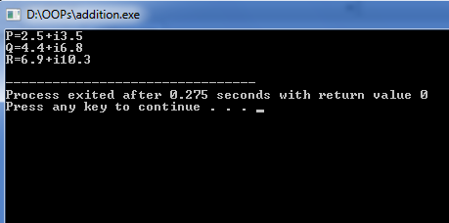
PROGRAM-15
#WAP to overload unary-operator
#include<iostream>
using namespace std;
class ope
{
int x,y,z;
public:
void get(int a,int b,int c)
{
x=a;
y=b;
z=c;
}
void display()
{
cout<<x<<" "<<y<<" "<<z<<endl;
}
void operator-()
{
x=-x;
y=-y;
z=-z;
}
};
int main()
{
ope p;
p.get(10,-40,30);
cout<<"P=";
p.display();
cout<<"P=";
-p;
p.display();
}
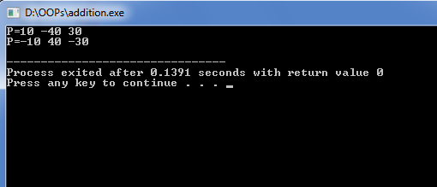
PROGRAM-16
#WAP to overload << and>> operator
#include<iostream>
using namespace std;
class Distance
{
private:
int feet,inches;
public:
Distance()
{
feet=0;
inches=0;
}
Distance(int f, int i)
{
feet=f;
inches=i;
}
friend ostream &operator<<( ostream &output,const Distance &D)
{
output<<"feet:"<<D.feet<<" Inches:"<<D.inches;
return output;
}
friend istream &operator>>( istream &input, Distance &D)
{
input>>D.feet>>D.inches;
return input;
}
};
int main()
{
Distance D1(11,10), D2(5,11), D3;
cout<<"Enter the value of object:";
cin>>D3;
cout<<"First distance:"<<D1<<endl;
cout<<"Second distance:"<<D2<<endl;
cout<<"Third distance:"<<D3<<endl;
}
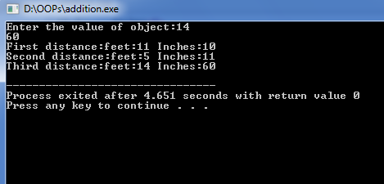
PROGRAM-17
#WAP to implement single inheritance using private mode
#include<iostream>
using namespace std;
class student
{
protected:
int roll_no;
public:
void get_num(int a)
{
roll_no=a;
}
void put_num()
{
cout<<"Roll number:"<<roll_no<<endl;
}
};
class test
{
protected:
float sub1,sub2;
public:
void get_marks(float x,float y)
{
sub1=x;
sub2=y;
}
void put_marks()
{
cout<<"Marks in Sub1:"<<sub1<<endl;
cout<<"Marks in Sub2:"<<sub2<<endl;
}
};
class result: private student,private test
{
float total;
public:
void getdata(int x,float y,float z)
{
get_num(x);
get_marks(y,z);
}
void display()
{
total=sub1+sub2;
put_num();
put_marks();
cout<<"Total:"<<total<<endl;
}
};
int main()
{
result student1;
student1.getdata(225,82.0,87.5);
student1.display();
}
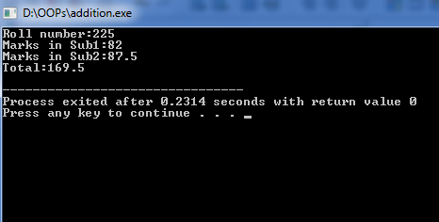
PROGRAM-18
#WAP to implement single inheritance using private mode
#include<iostream>
using namespace std;
class student
{
protected:
int roll_no;
public:
void get_num(int a)
{
roll_no=a;
}
void put_num()
{
cout<<"Roll number:"<<roll_no<<endl;
}
};
class test:public student
{
protected:
float sub1,sub2;
public:
void get_marks(float x,float y)
{
sub1=x;
sub2=y;
}
void put_marks()
{
cout<<"Marks in Sub1:"<<sub1<<endl;
cout<<"Marks in Sub2:"<<sub2<<endl;
}
};
class result:public test
{
float total;
public:
void display()
{
total=sub1+sub2;
put_num();
put_marks();
cout<<"Total:"<<total<<endl;
}
};
int main()
{
result student1;
student1.get_num(21);
student1.get_marks(95.5,67.5);
student1.display();
}
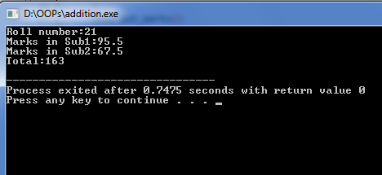
PROGRAM-19
#WAP to create class employee with name and salary. Make a class manager inherit from employee. Add data member department. Make class executive inherit from manager and define a function tostring() which displays all the details of manager and employee
#include<iostream>
#include<string>
using namespace std;
class employee
{
public:
string name;
long salary;
};
class manager:public employee
{
public:
string department;
int a;
void input()
{
cout<<"Enter name:";
getline(cin,name);
cout<<"Enter department:";
getline(cin,department);
cout<<"Enter salary:";
cin>>salary;
}
};
class Executive:public manager
{
public:
void tostring()
{
input();
cout<<"\nExecutive\n";
cout<<"Name:"<<name<<endl<<"Department:"<<department<<endl<<"Salary:"<<salrry;
}
};
int main()
{
Executive a;
a.tostring();
}
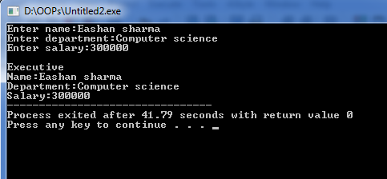
PROGRAM-20
#WAP to print prime numbers till a given number
#include<iostream>
#include<string>
using namespace std;
int main()
{
int a;
cout<<"Enter the range:";
cin>>a;
bool prime=0;
for(int i=2;i<=a;i++)
{
for(int j=2;j<(i/2+1);j++)
{
if(i%j==0)
{
prime=1;
break;

}
}
if(!prime)
{
cout<<i<<endl;
}
prime=0;
}
}
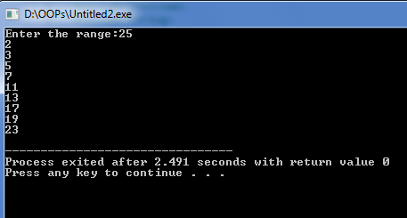
PROGRAM-21
#WAP to calculate distance between two points using binary-overloading
#include<iostream>
#include<string>
using namespace std;
class point
{
int x,y;
public:
point(){}
point(int a,int b)
{
x=a;
y=b;
}
point operator-(point temp1)
{
point temp2;
temp2.x=x-temp1.x;
temp2.y=y-temp1.y;
return temp2;
}
void display()
{
cout<<"Difference between points:"<<endl;
cout<<"X="<<x<<endl<<"Y="<<y;
}
};
int main()
{
point x,y,z;
int a,b,c,d;
cout<<"Enter X1:";
cin>>a;
cout<<"Enter Y1:";
cin>>b;
x=point(a,b);
cout<<"Enter X2:";
cin>>c;
cout<<"Enter Y2:";
cin>>d;
y=point(c,d);
z=x-y;
z.display();
}
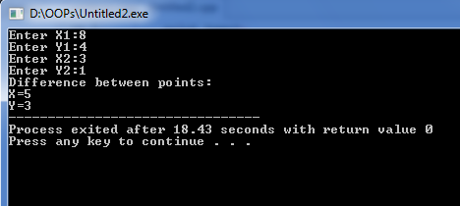
PROGRAM-22
#Take two strings s1=”MRIU” and s2=”FARIDABAD”.ADD s1 and s2 into s3 using copy constructor. Compare the string with a string entered by the user and state if they are same or not. Overload << to print the output string after concatenation.
#include<iostream>
#include<string>
using namespace std;
class STRING
{
string s,s1,s2;
public:
STRING(){}
STRING(string a)
{
s=a;
}
STRING(STRING temp1,STRING temp2)
{
s1=temp1.s;
s2=temp2.s;
s=s1+s2;
}
bool operator==(STRING temp2)
{
if(s==temp2.s)
return true;
else
return false;
}
friend ostream &operator<<(ostream &output,STRING s)
{
cout<<"S1:"<<s.s1<<endl;
cout<<"S2:"<<s.s2<<endl;
cout<<"S3:"<<s.s<<endl;
}
};
int main()
{
STRING x,y,z;
string a,b;
cout<<"Enter S1:";
cin>>a;
x=STRING(a);
cout<<"Enter S2:";
cin>>b;
y=STRING(b);
z=STRING(x,y);
cout<<z;
if(x==y)
cout<<"They are same";
else
cout<<"They are not same";
}
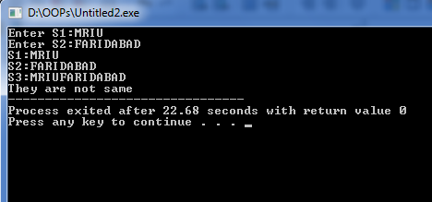
PROGRAM-23
#WAP to implement multiple inheritance
#include<iostream>
using namespace std;
class student
{
protected:
int roll_no;
public:
void get_num(int a)
{
roll_no=a;
}
void put_num()
{
cout<<"Roll number:"<<roll_no<<endl;
}
};
class extra
{

protected:
float sube;
public:
void get_emarks(float x)
{
sube=x;
}

};
class academic
{
protected:
float suba;
public:
void get_amarks(float y)
{
suba=y;
}
};
class result:public student,public extra,public academic
{
public:
void display()
{
cout<<"Roll no:"<<roll_no<<endl;
cout<<"Academic marks:"<<suba<<endl;
cout<<"Extra Curricular marks:"<<sube<<endl;
cout<<"Result:"<<sube+suba<<endl;
}
};

int main()
{
result student1;
student1.get_num(212);
student1.get_emarks(93.5);
student1.get_amarks(77.5);
student1.display();
}
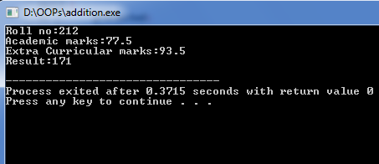
PROGRAM-24
#WAP to implement multilevel inheritance
#include<iostream>
using namespace std;
class student
{
protected:
int roll_no;
public:
void get_num(int a)
{
roll_no=a;
}
void put_num()
{
cout<<"Roll number:"<<roll_no<<endl;
}
};
class test:virtual public student
{

protected:
float part1,part2;
public:
void get_marks(float x,float y)
{
part1=x;
part2=y;
}
void put_marks()
{
cout<<"Marks obtained:\n"<<"Part1:"<<part1<<endl<<"Part 2:"<<part2<<endl;
}

};
class sports:virtual public student
{
protected:
float score;
public:
void get_score(float z)
{
score=z;
}
void put_score()
{
cout<<"Sports Score:"<<score<<endl;
}
};
class result:public test,public sports
{
float total;
public:
void display()
{
total=part1+part2+score;
put_num();
put_marks();
put_score();
cout<<"Total Score:"<<total<<endl;
}
};
int main()
{
result student1;
student1.get_num(212);
student1.get_marks(93.5,72.5);
student1.get_score(67);
student1.display();
}
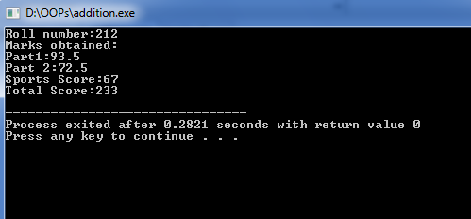
PROGRAM-28
# WAP to implement the concept of ‘this’ pointer
#include<iostream>
using namespace std;
/* local variable is same as a member's name */
class Test
{
private:
int x;
public:
void setX (int x)
{
// The 'this' pointer is used to retrieve the object's x
// hidden by the local variable 'x'
this->x = x;
}
void print() { cout<< "x = " << x <<endl; }
};
int main()
{
Test obj;
int x = 20;
obj.setX(x);
obj.print();
return 0;
}
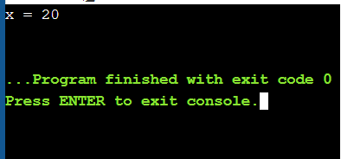
PROGRAM-29
# WAP to swap two integers using templates
#include<iostream>
using namespace std;
template<class T>
class example
{
public:
void swap(T &x, T &y)
{
T temp=x;
x=y;
y=temp;
}
};
int main()
{
int x=20,y=10;
float a=1.6, b=1.9;
example<int>example1;
example<float>example2;
cout<<"before swap: "<<endl;
cout<<"x = "<<x<<endl<<"y = "<<y<<endl;
cout<<"a = "<<a<<endl<<"b = "<<b<<endl;
example1.swap(x,y);
example2.swap(a,b);
cout<<"after swap: "<<endl;
cout<<"x = "<<x<<endl<<"y = "<<y<<endl;
cout<<"a = "<<a<<endl<<"b = "<<b<<endl;
}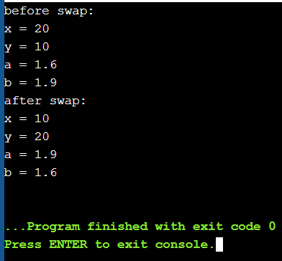
PROGRAM-30
#WAP which takes 2 arguments one type of template and other non template type
#include <iostream>
using namespace std;
template<class A>
int bsort(A arr[],int n)
{
for (int i=0;i<n-1;i++)
{
for (int j=0;j<n-1;j++)
{
if (arr[j]>arr[j+1])
{
A a=arr[j];
arr[j]=arr[j+1];
arr[j+1]=a;
}
}
}
return 0;
}
int main()
{
int size=5;
int input[]={10,56,23,6,89,54};
bsort(input, size);
for(int i=0;i<size;i++)
{
cout<<input[i]<<endl;
}
}
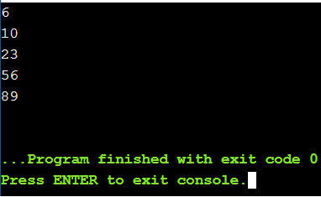
PROGRAM-31
#Demonstrate overloading of template functions
#include <iostream>
using namespace std;
template<class x>
void functionn(x a,x b)
{
cout<<"function value:(x a,x b)"<<endl;
}
template<class x,class y>
void functionn(x a,y b)
{
cout<<"function value:(x a,y b)"<<endl;
}
int main()
{
functionn(10,9);
functionn(4.444,'1');
return 0;
}
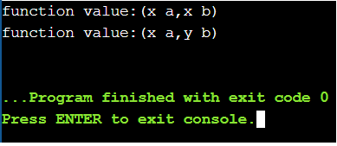
PROGRAM-32
# Write a program with the following:
a. A function to read two double type numbers.
b. A function to calculate division of these two double number.
c. a try block to throw an exception when wrong data is keyed in
d. try block to detect and throw an exception if divide by zero
e. appropriate catch block to handle the exceptions thrown.
#include<iostream>
using namespace std;
double divide (double a, double b)
{
double c;
c=a/b;
try
{
if(b==0)
{
throw (b);
}
else if (b>100)
{
throw (b);
}
else if (a>100)
{
throw (a);
}
else
{
cout<<"result(a/b):"<<c<<endl;
}
}
catch(double d)
{
if (d==a)
{
cout<<"a>100 error"<<endl;
}
else if (d==0)
{
cout<<"b is 0 error"<<endl;
}
else if (d==b)
{
cout<<"b>100 error"<<endl;
}
}
return 0;
}
int main ()
{
double a,b;
int i;
cin>>i;
while(i--)
{
cout<<"enter value of a and b but less than 100"<<endl;
cin>>a>>b;
divide(a,b);
}
}
33)#include<iostream>
using namespace std;
class Father
{
protected :
int age;
public:
Father(){}
Father(int x)
{
age= x;
}
virtual void iam()
{
cout<<"I AM THE FATHER , my age is :"<<age<<endl;
}

};
class Son : public Father
{
protected :
int age;
public:
Son(){}
Son(int x)
{
age =x;
}
virtual void iam()
{
cout<<"I AM Son , my age is :"<< age <<endl;
}
};
class Daughter : public Father
{
protected :
int age;
public:
Daughter(){}
Daughter(int x)
{
age = x;
}
virtual void iam()
{
cout<< " I AM Daughter, my age is :"<< age<<endl;
}
};
int main()
{
Father F(6|4);
Son S(9);
Daughter D(29);
cout<<"iam from Father"<<endl;
F.iam();
cout<<"iam from son"<<endl;
S.iam();
cout<<" iam from Daughter"<<endl;
D.iam();
Father *ptrF =&S;
cout<<"Pointer FROM FATHER TO SON"<<endl;
ptrF->iam();
cout<<"Pointer FROM FATHER TO DAUGHTER"<<endl;
ptrF =&D;
ptrF->iam();
}
